**DAILY ONLINE ACTIVITIES SUMMARY**

|  |  |  |  |  |  |  |  |  |
| --- | --- | --- | --- | --- | --- | --- | --- | --- |
| **Date:** | **12-6-2020** | | | | | **Name:** | **poojashree** | |
| **Sem & Sec** | **8th sem A sec** | | | | | **USN:** | **4al16cs065** | |
| **Online Test Summary** | | | | | | | | |
| **Subject** | | **bda** | | | | | | |
| **Max. Marks** | | **30** | | **Score** | | | **22** | |
| **Certification Course Summary** | | | | | | | | |
| **Course** | **Introduction to cyber security** | | | | | | | |
| **Certificate Provider** | | | **Great learning academy** | | **Duration** | | | **5.5hr** |
| **Coding Challenges** | | | | | | | | |
| **Problem Statement:**  **1.** **C program to find all the triplets with the given sum** | | | | | | | | |
| **Status:completed** | | | | | | | | |
| **Uploaded the report in Github** | | | | | **yes** | | | |
| **If yes Repository name** | | | | | **Poojashree** | | | |
| **Uploaded the report in slack** | | | | | **yes** | | | |

**Online test**

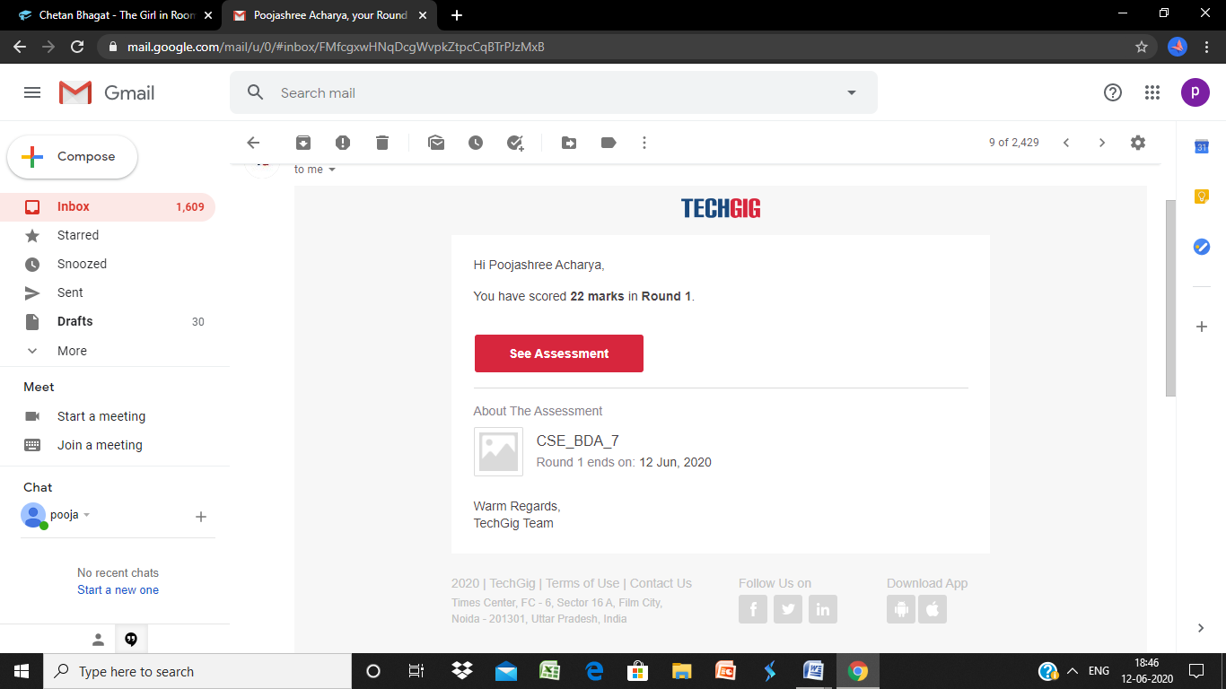

**Certification course**



**Coding**

**Program 1**

**/ /C program to find all the triplets with the given sum**

**#include<stdio.h>**

**void find_all_triplets(int arr[], int n, int sum)**

**{**

**for (int i = 0; i < n – 2; i++)**

**{**

**for (int j = i + 1; j < n – 1; j++)**

**{**

**for (int k = j + 1; k < n; k++)**

**{**

**if (arr[i] + arr[j] + arr[k] == sum)**

**{**

**printf(“%d,%d,%d\n”,arr[i],arr[j],arr[k]);**

**}}}}}**

**int main()**

**{**

**int n, sum;**

**printf(“\nEnter the number of elements : “);**

**scanf(“%d”,&n);**

**int arr[n];**

**printf(“\nInput the array elements : “);**

**for(int i = 0; i < n; i++)**

**{**

**scanf(“%d”,&arr[i]);**

**}**

**printf(“\nEnter the sum value : “);**

**scanf(“%d”,&sum);**

**printf(“\nThe triplets are \n “);**

**find_all_triplets(arr, n, sum);**

**return 0;**

**}**